1. **Agenda**:
   1. What is method reference?
   2. How to use them with lambda expression?
2. Method reference was mainly used with lambda expression.
3. When to use?
   1. Sometimes, the business logic that you want to write inside a lambda expression is already inside an already existing method.
4. 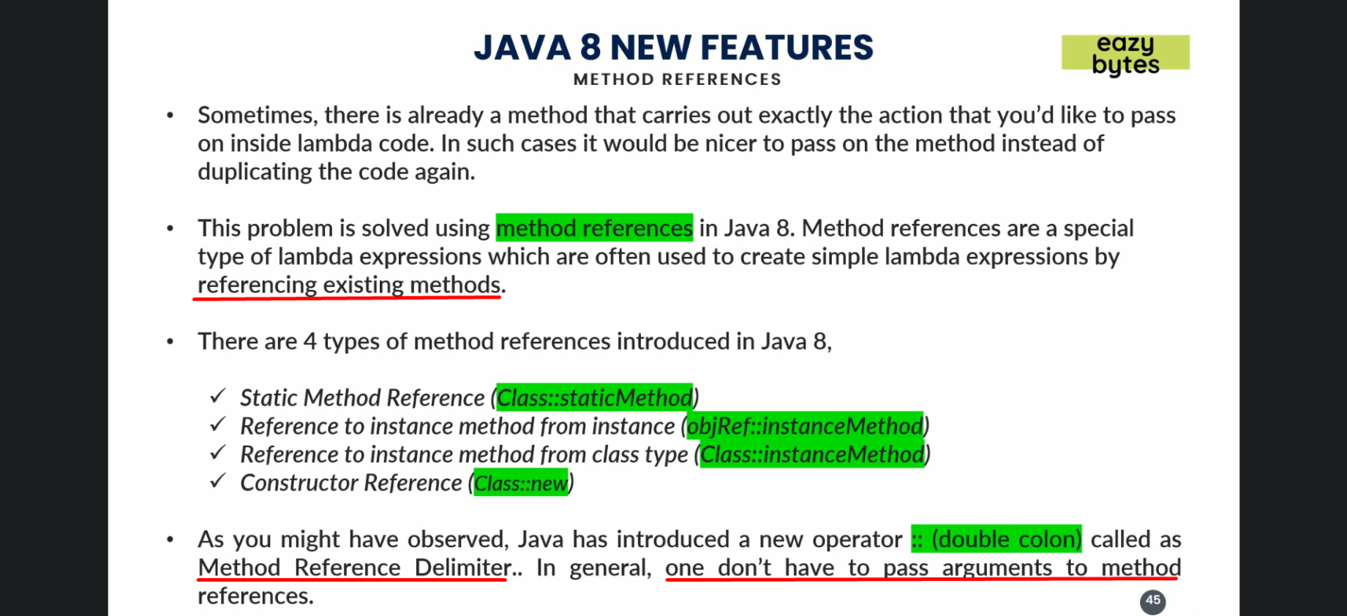
5. Static Method Reference:  
   